Caracas, 8th July, 2007

Eng. Nikolaos Giotis
Technical University of Crete
Greece

Dear Mr. Giotis:

We are pleased to invite you to carry out a research stay in our Central University of Venezuela, during the months of September and October 2007.

This research stay will be in the framework of our ALPHA Project Elbenet, supported by the European Community, and devoted to the boundary elements research. Your visit to Venezuela is welcomed and we expect that you will contribute to our research.

Looking forward to hear on you soon, I remain

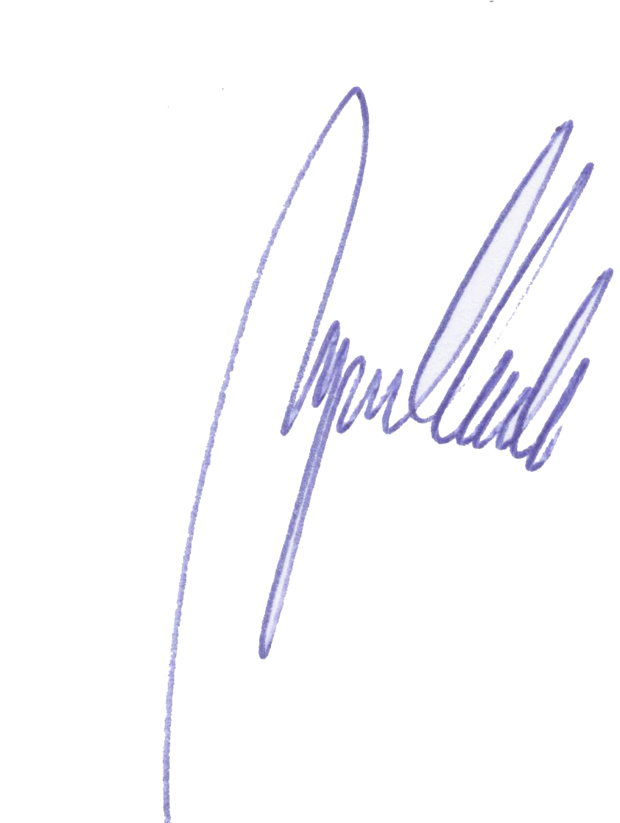
Yours sincerely

M. Cerrolaza
Head

